**DEPARTMENT OF COMPUTER SCIENCE & ENGINEERING**

**FACULTY OF ENGINEERING & TECHNOLOGY**

**GURUKUL KANGRI (DEEMED TO BE UNIVERSITY)**

**HARIDWAR**



**SESSION (2021-2022)**

**REPORT-** MINOR PROJECT

**Guided By- Submitted By-**

*MR. NISHANT KUMAR RACHIT KAUSHIK (186301057)*

*(ASST. PROF. C.S.E. DEPT.)*

*Team Members:*

1) RACHIT KAUSHIK (186301057)

2) MD. SAJID ANIS (186301045)

3) PANKAJ SAGAR (186301049)

4) ADARSH TIWARI (186301009)

5) RAJEEV SINGH (186301058)

Certificate

This is to certify that the project work in this file is done by combined efforts of me and my team members and we have not copied it from anywhere. This work is done by me and my team and I have not presented it anywhere else.

Rachit Kaushik

Branch : CSE

Roll No.- 186301057

Certificate

This is to certify that the work in this file is done under my supervision and hasn’t been copied from anywhere or presented anywhere for any sort of benefit.

Mr. Nishant Kumar

Assistant Professor

Department of Computer Science and Engineering

Faculty of Engineering and Technology

|  |  |
| --- | --- |
| **Table of Contents** | **Page No** |
|  |  |
| **Abstract** | 2 |
|  |  |
| **1** **Introduction** |  |
| 1.1Objective | 3 |
| 1.3 Scope | 3 |
| 1.3 Purpose | 3 |
| 1.4 Problem Statement | 3 |
| 1.5 Outcome | 4 |
|  |  |
| **2 Methodology** | 5 |
|  |  |
| **3 Literature Survey** | 6 |
|  |  |
| **4 Design** |  |
| 4.1 Module Dependency Diagrams | 7-10 |
|  |  |
| **5** **Implementation Requirements** |  |
| 5.1 Hardware Requirements | 11 |
| 5.3 Platform Requirements | 11 |
| 5.3 Software Requirements | 12 |
| 5.4 Database Requirements | 13-15 |
|  |  |
| **6** **Lay-out** |  |
| 6.1 Snapshot | 16-23 |
|  |  |
| **7** **Code Glimpses** |  |
| 7.1 Frontend | 24-29 |
| 7.2 Backend Endpoints | 30-33 |
|  |  |
| **8 References** | 34 |

# Abstract

This project is a business solution for an enterprise (start-up) named **“Helping Hands”** which provides services like car washing, sofa cleaning, sanitization, plumbing, carpentry, etc. at door-step. It will allow customers to book different services from available slots. A receipt containing the booked services and the contact information of the servicemen who will perform those services will be sent to the email address and the mobile no. of the customer.

# INTRODUCTION

## Objective

The main objective of this project is to build a dynamic & responsive website which provides the functionality of :

* booking various services to the customer
* managing the services and bookings to the admin

## Scope

* + - Can be used to book services
    - Can be used to schedule appointments

## Purpose

In the small towns and cities where the big unicorns like “Urban–Clap” do not provide services, small “start-ups” are playing a vital role. One such start-up is “Helping Hands” which provide services like car washing, sofa cleaning, sanitization, plumbing, carpentry, etc. at door-step in the Moradabad city of Uttar Pradesh. In order to increase the no. of customers and spread the reach of their business it needs an online platform which allows the customers to book services easily. The purpose of this project is to build a dynamic & responsive website which provides the functionality of :

* booking various services to the customer
* managing the services and bookings to the admin

## Problem Statement

To build a dynamic & responsive website which provides the functionality of :

* booking various services to the customer
* managing the services and bookings to the admin

## Outcome

The service provider will be able to expand his business as a result of the increased no. of customers and the customers will be easily able to book services which earlier was done using calls which had many problems:

* consuming more time
* waiting for call to be picked due to more people calling at same time
* creating confusion at times about the price

# METHODOLOGY

The proposed system will have the following working principles:

#### For Customers:

* Create a user account (Sign-Up)
* Login
* Book Services
* Cancel Bookings
* View all his bookings

#### For Admins:

* Add another admin
* Login
* View pending bookings
* View completed bookings
* View bookings to be completed today
* View new bookings done today

**LITERATURE SURVEY**

## Components of Web Application

The main components of the WebApp are:

* + - UI
    - Back-end

**User Interface (UI) :** The user interface is simple with not much colors. It is kept as simple as possible so as to make it look like a decent and minimalistic interface with easy to use. The UI is designed in such a way for a smooth user experience. The UI is created using React framework.

**Back-end:**

There are two phases working in the background:

* + - MiddleWare and Controllers
    - Database

**Middlewares and Controllers** : Whenever a user tries to access the services or request for any service, the request is first validated using all the middlewares which look for any user input error or any required input errors, then the request is passed on to the controllers for the process. The controllers process the request and if any request needs data from database, its the controller responsibility to look for any data invalidation before accessing the database. Every service has its own controller and middleware.

**Database**: Database is where the actual data resides. We are using mongodb as our database, which is a nosql database. The benefit of using nosql database over sql database are its flexible data models, horizontal scaling, fast queries and easy to use in any kind of application.

**DESIGN**

**4.1 Module Dependency Diagrams:**

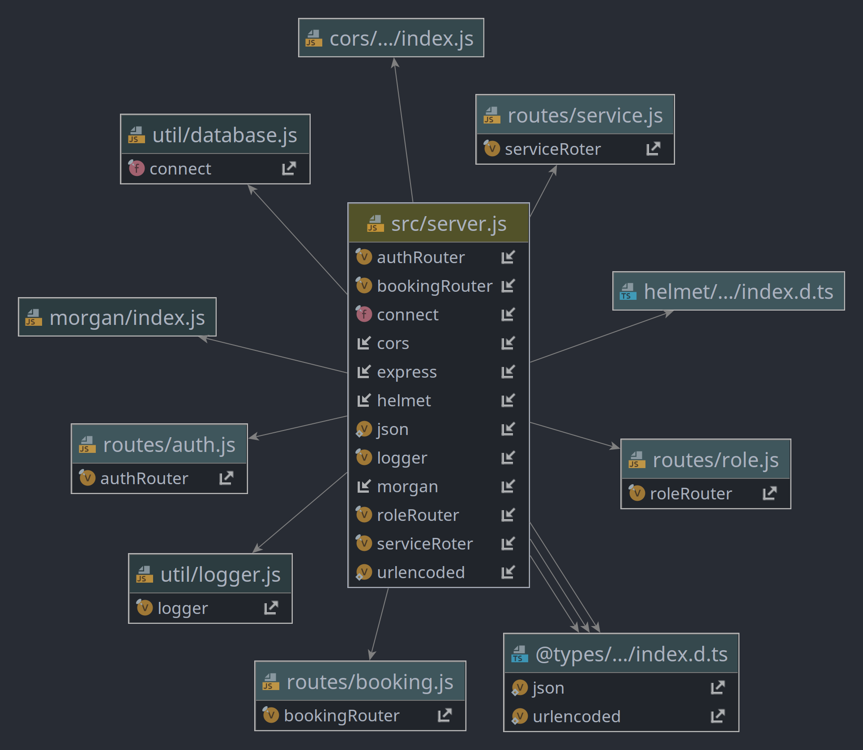

***Fig 4.1(A): Source Server***

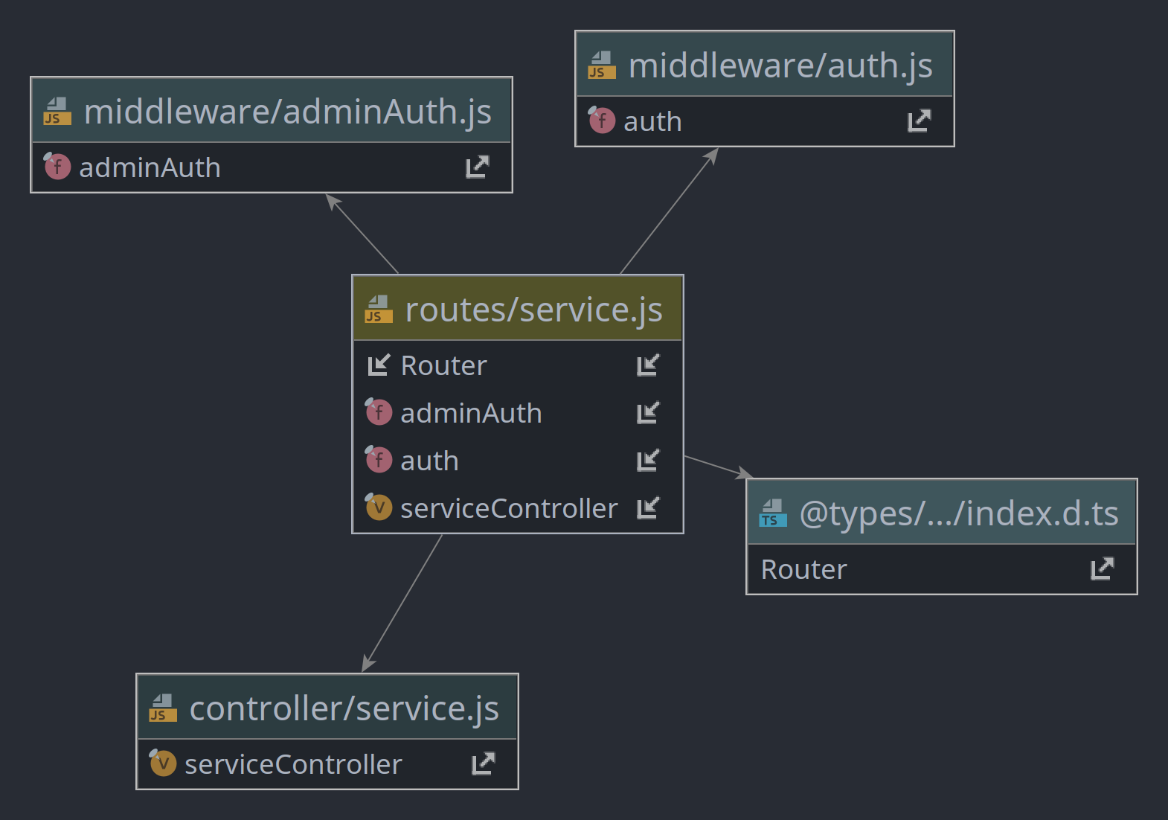

***Fig 4.1(B):*** Route Service

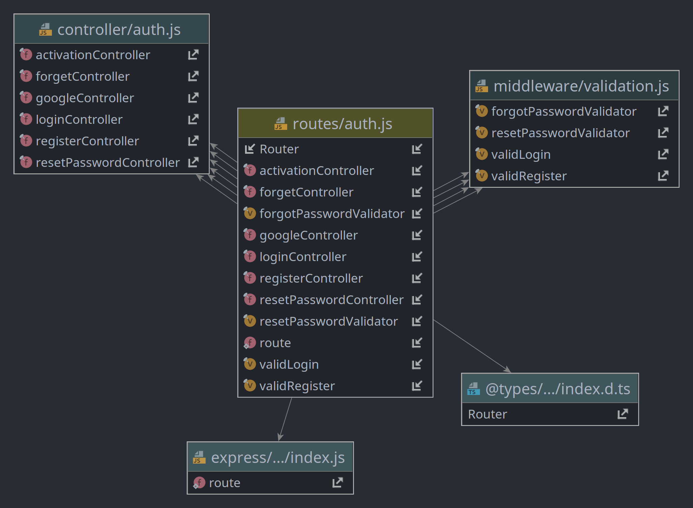

***Fig 4.1(C):*** Route Authorization

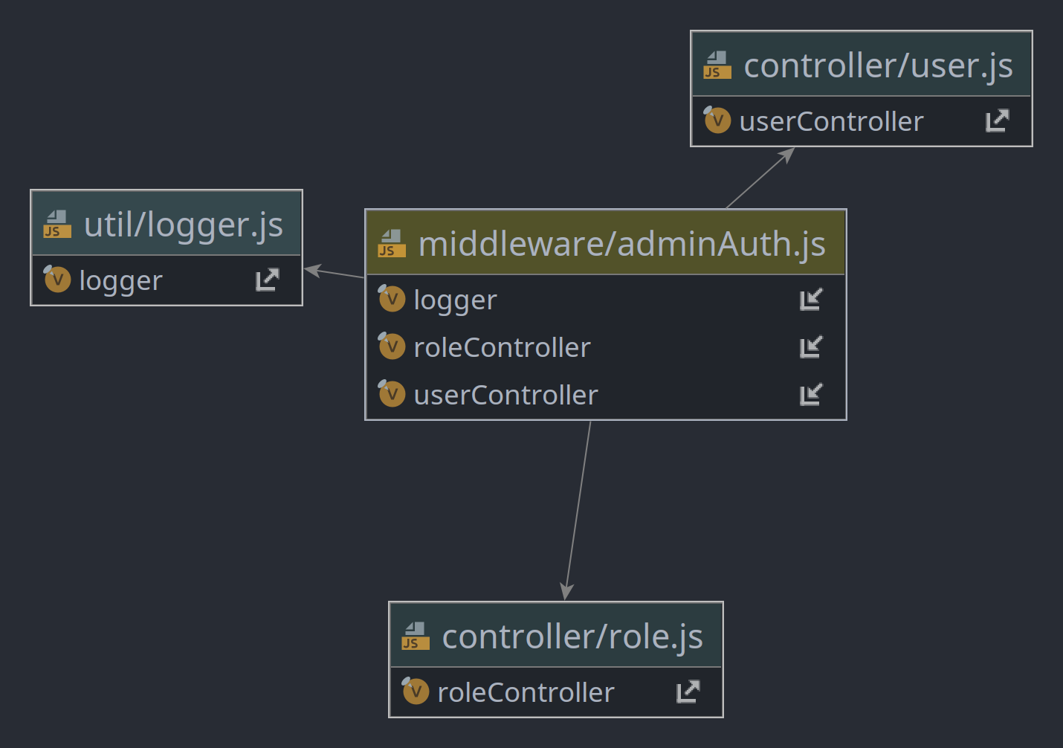

***Fig 4.1(D) :***Middleware Admin Authorization

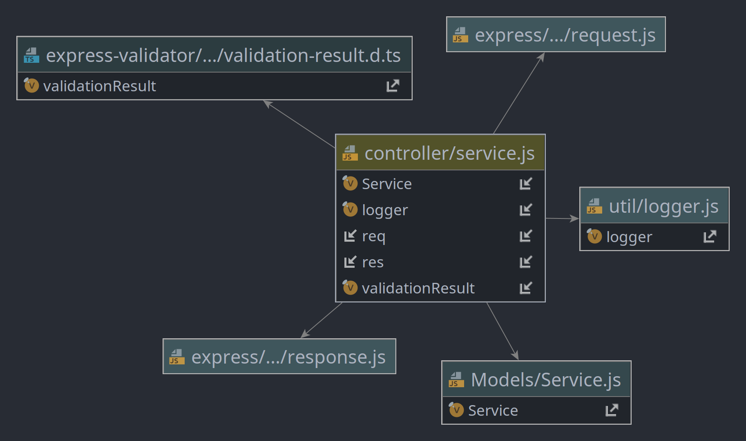

***Fig 4.1(E):*** Controller Service

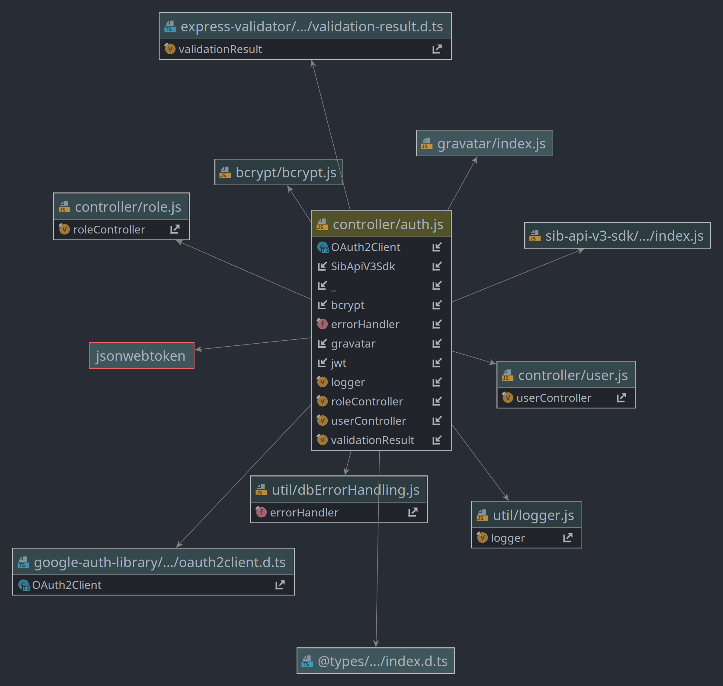

***Fig 4.1(F):*** Controller Authorization

## REQUIREMENT ANALYSIS

To be used efficiently, all computer software needs certain hardware components or other soft- ware resources to be present on a computer. These prerequisites are known as (computer) system requirements and are often used as a guideline as opposed to an absolute rule. Most software defines two sets of system requirements: minimum and recommended.

## Hardware Requirements

The most common set of requirements defined by any operating system or software application is the physical computer resources, also known as hardware, A hardware requirements list is often accompanied by a hardware compatibility list (HCL), especially in the case of operating systems. An HCL lists tested, compatible, and sometimes incompatible hardware devices for a particular operating system or application.

COMPONENTS : System

MINIMUM : Intel Core i3-3100 3rd Generation, 2GB RAM

## Platform Requirements

* + 1. **Supporting Operating System**

The supported Operating Systems for client include: Windows 10, Linux, MacOs.

We as developer of our project will follow the given responsibilities:

1. Completing the tasks within the deadlines.
2. Informing our internal and external guides regularly about our performance.
3. Maintaining the logbook.
4. Implementing of the project on well planned manner.
5. Dividing the tasks among project equally

## Software Requirements

The Software Requirements in this project include

1. NodeJS
2. Express Framework ( Backend )
3. React Framework ( Frontend )
4. MongoDB (Database)
5. Browser ( Firefox > 52.0 or Chrome > 63.0)

Software requirements deal with defining software resource requirements and prerequisites that need to be installed on a computer to provide optimal functioning of an application. These requirements or prerequisites are generally not included in the software installation package and need to be installed separately before the software is installed.

* **NodeJS -** Node.js is an [open-source](https://en.wikipedia.org/wiki/Open-source_software), [cross-platform](https://en.wikipedia.org/wiki/Cross-platform), [back-end](https://en.wikipedia.org/wiki/Front_end_and_back_end) [JavaScript](https://en.wikipedia.org/wiki/JavaScript) [runtime environment](https://en.wikipedia.org/wiki/Runtime_system) that runs on the [V8 engine](https://en.wikipedia.org/wiki/V8_(JavaScript_engine)) and executes JavaScript code outside a [web browser](https://en.wikipedia.org/wiki/Web_browser). Node.js lets developers use JavaScript to write command-line tools and for [server-side scripting](https://en.wikipedia.org/wiki/Server-side_scripting)`—running scripts server-side to produce [dynamic web page](https://en.wikipedia.org/wiki/Dynamic_web_page) content before the page is sent to the user's web browser. Consequently, Node.js represents a "JavaScript everywhere" paradigm,[[6]](https://en.wikipedia.org/wiki/Node.js" \l "cite_note-6) unifying [web-application](https://en.wikipedia.org/wiki/Web_application) development around a single programming language, rather than different languages for server-side and client-side scripts. As an asynchronous event-driven JavaScript runtime, Node.js is designed to build scalable network applications.
* **React Framework**

### **Declarative**

React makes it painless to create interactive UIs. Design simple views for each state in your application, and React will efficiently update and render just the right components when your data changes.

### **Component-Based**

Build encapsulated components that manage their own state, then compose them to make complex UIs.Since component logic is written in JavaScript instead of templates, you can easily pass rich data through your app and keep state out of the DOM.

### **Learn Once, Write Anywhere**

We don’t make assumptions about the rest of your technology stack, so you can develop new features in React without rewriting existing code.

* **Express Framework**

**Web Applications**

Express is a minimal and flexible Node.js web application framework that provides a robust set of features for web and mobile applications.

### **APIs**

With a myriad of HTTP utility methods and middleware at your disposal, creating a robust API is quick and easy.

### **Performance**

Express provides a thin layer of fundamental web application features, without obscuring Node.js features that you know and love.

## Database Requirements

**MongoDB** is a [source-available](https://en.wikipedia.org/wiki/Source-available) [cross-platform](https://en.wikipedia.org/wiki/Cross-platform) [document-oriented database](https://en.wikipedia.org/wiki/Document-oriented_database) program. Classified as a [NoSQL](https://en.wikipedia.org/wiki/NoSQL) database program, MongoDB uses [JSON](https://en.wikipedia.org/wiki/JSON)-like documents with optional [schemas](https://en.wikipedia.org/wiki/Database_schema). MongoDB is developed by [MongoDB Inc.](https://en.wikipedia.org/wiki/MongoDB_Inc.) and licensed under the [Server Side Public License](https://en.wikipedia.org/wiki/Server_Side_Public_License) (SSPL).

## Main features

### **Ad-hoc queries**

MongoDB supports field, [range query](https://en.wikipedia.org/wiki/Range_query_(database)), and [regular-expression](https://en.wikipedia.org/wiki/Regular_expression) searches. Queries can return specific fields of documents and also include user-defined [JavaScript](https://en.wikipedia.org/wiki/JavaScript) functions. Queries can also be configured to return a random sample of results of a given size.

### **Indexing**

Fields in a MongoDB document can be indexed with primary and secondary indices or index.

### **Replication**

MongoDB provides high availability with replica sets. A replica set consists of two or more copies of the data. Each replica-set member may act in the role of the primary or secondary replica at any time. All writes and reads are done on the primary replica by default. Secondary replicas maintain a copy of the data of the primary using built-in replication. When a primary replica fails, the replica set automatically conducts an election process to determine which secondary should become the primary. Secondaries can optionally serve read operations, but that data is only eventually consistent by default.

If the replicated MongoDB deployment only has a single secondary member, a separate [daemon](https://en.wikipedia.org/wiki/Daemon_(computing)) called an *arbiter* must be added to the set. It has a single responsibility, which is to resolve the election of the new primary. As a consequence, an idealized distributed MongoDB deployment requires at least three separate servers, even in the case of just one primary and one secondary.

### **Load balancing**

MongoDB scales horizontally using [sharding](https://en.wikipedia.org/wiki/Sharding). The user chooses a shard key, which determines how the data in a collection will be distributed. The data is split into ranges (based on the shard key) and distributed across multiple shards. (A shard is a master with one or more replicas.) Alternatively, the shard key can be hashed to map to a shard – enabling an even data distribution.

MongoDB can run over multiple servers, [balancing the load](https://en.wikipedia.org/wiki/Load_balancing_(computing)) or duplicating data to keep the system up and running in case of hardware failure.

### **File storage**

MongoDB can be used as a [file system](https://en.wikipedia.org/wiki/File_system), called [GridFS](https://en.wikipedia.org/w/index.php?title=GridFS&action=edit&redlink=1), with load balancing and data replication features over multiple machines for storing files.

This function, called [grid file system](https://en.wikipedia.org/wiki/Grid_file_system), is included with MongoDB drivers. MongoDB exposes functions for file manipulation and content to developers. GridFS can be accessed using mongofiles utility or plugins for [Nginx](https://en.wikipedia.org/wiki/Nginx) and [lighttpd](https://en.wikipedia.org/wiki/Lighttpd). GridFS divides a file into parts, or chunks, and stores each of those chunks as a separate document.

### **Aggregation**

MongoDB provides three ways to perform aggregation: the aggregation pipeline, the map-reduce function, and single-purpose aggregation methods.

[Map-reduce](https://en.wikipedia.org/wiki/Map-reduce) can be used for batch processing of data and aggregation operations. But according to MongoDB's documentation, the Aggregation Pipeline provides better performance for most aggregation operations.

The aggregation framework enables users to obtain the kind of results for which the [SQL](https://en.wikipedia.org/wiki/SQL) GROUP BY clause is used. Aggregation operators can be strung together to form a pipeline – analogous to [Unix pipes](https://en.wikipedia.org/wiki/Pipeline_(Unix)). The aggregation framework includes the $lookup operator which can join documents from multiple collections, as well as statistical operators such as standard deviation.

### **Server-side JavaScript execution**

JavaScript can be used in queries, aggregation functions (such as [MapReduce](https://en.wikipedia.org/wiki/MapReduce)), and sent directly to the database to be executed.

### **Capped collections**

MongoDB supports fixed-size collections called capped collections. This type of collection maintains insertion order and, once the specified size has been reached, behaves like a [circular queue](https://en.wikipedia.org/wiki/Circular_queue).

### **Transactions**

MongoDB claims to support multi-document ACID transactions since the 4.0 release in June 2018. This claim was found to not be true as MongoDB violates [snapshot isolation](https://en.wikipedia.org/wiki/Snapshot_isolation)

## LAY-OUT

**6.1 Snapshots:**

#### 6.1.1(a)



**6.1.1(b)**



**6.1.2**



#### 6.1.3

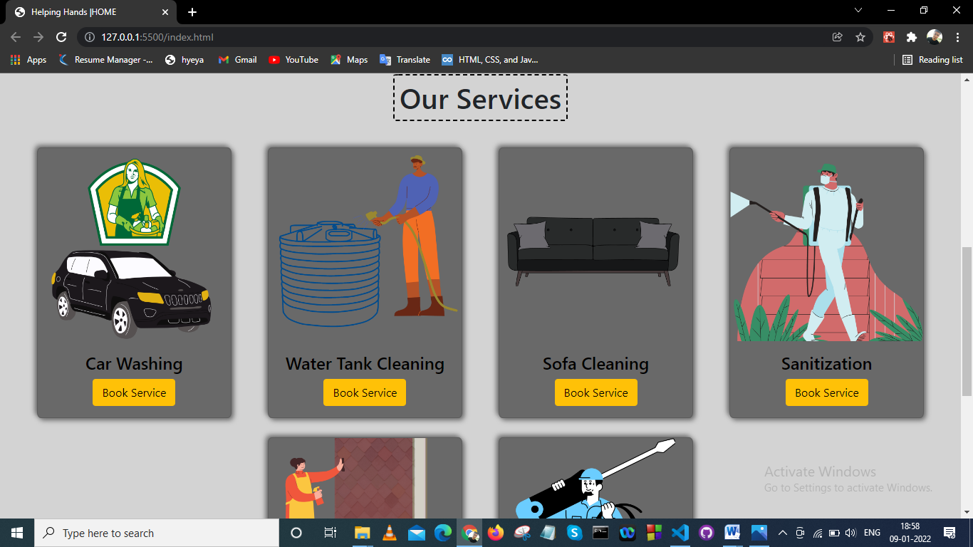

**6.1.4**

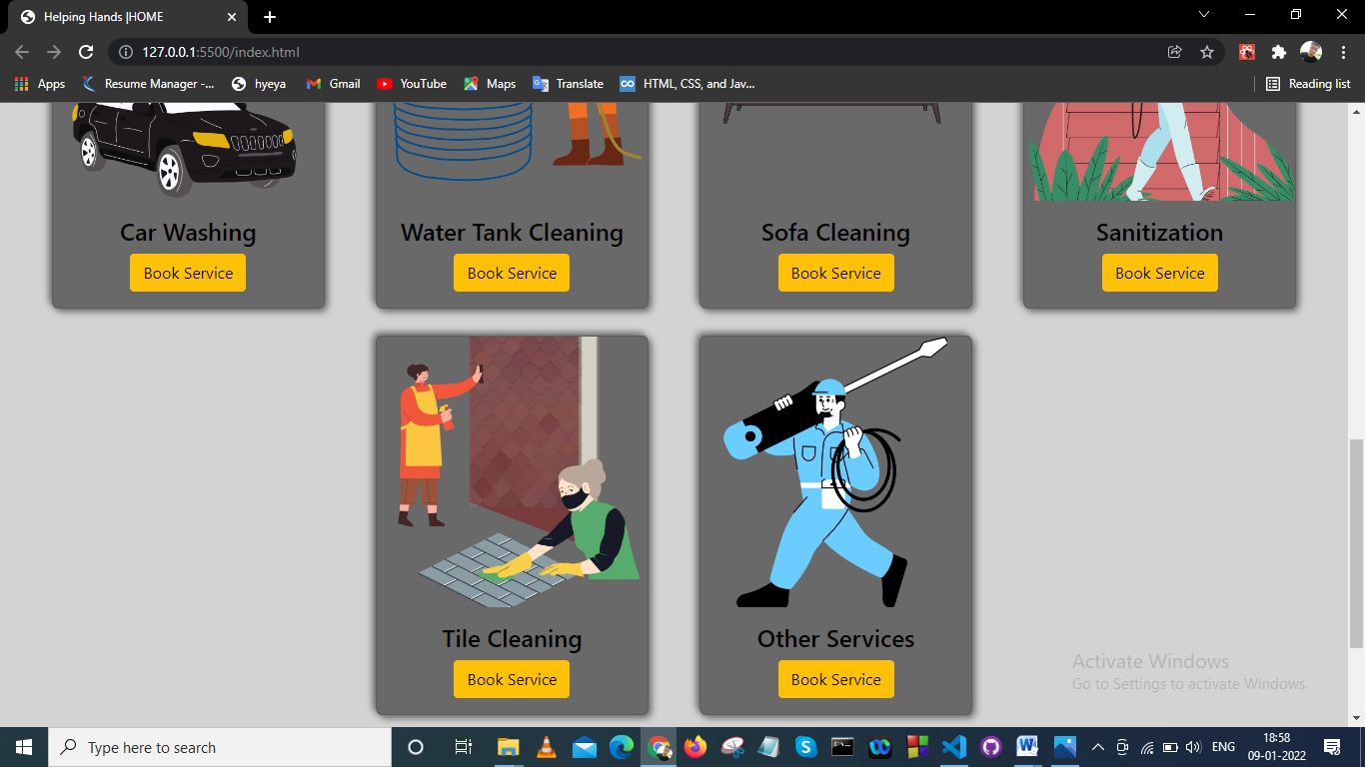

#### 6.1.5

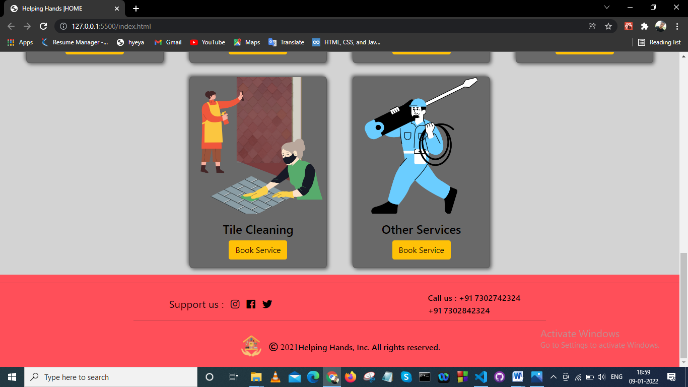

**6.1.6**

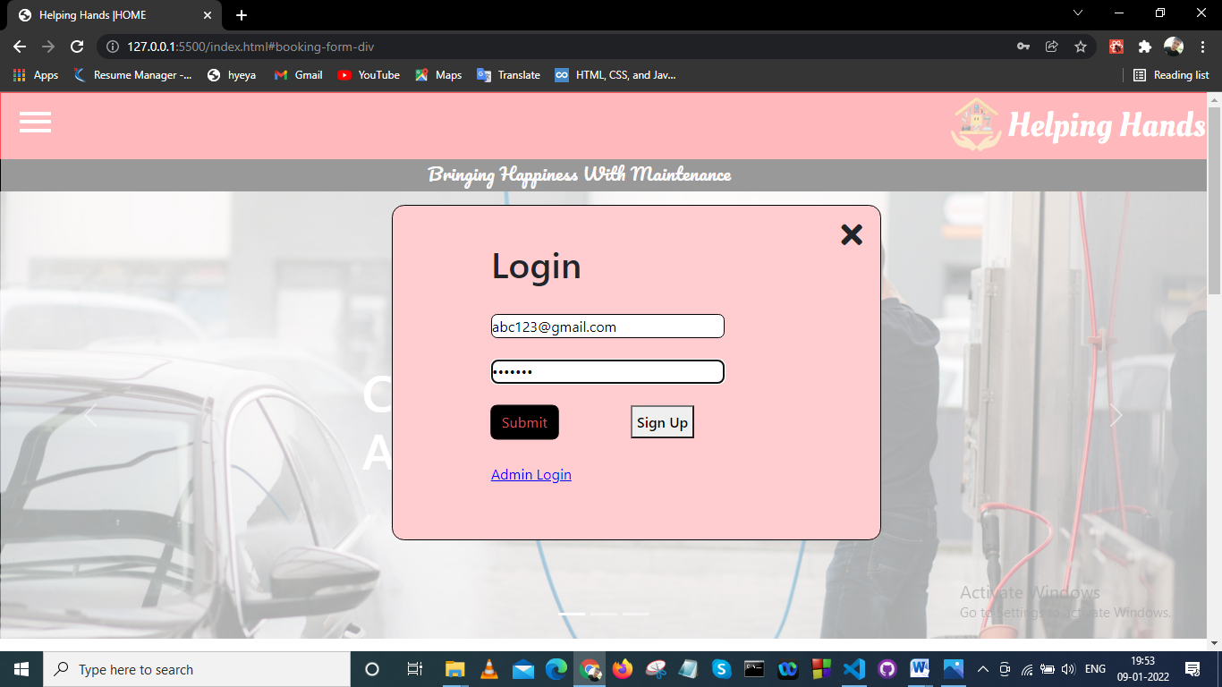

**6.1.7**

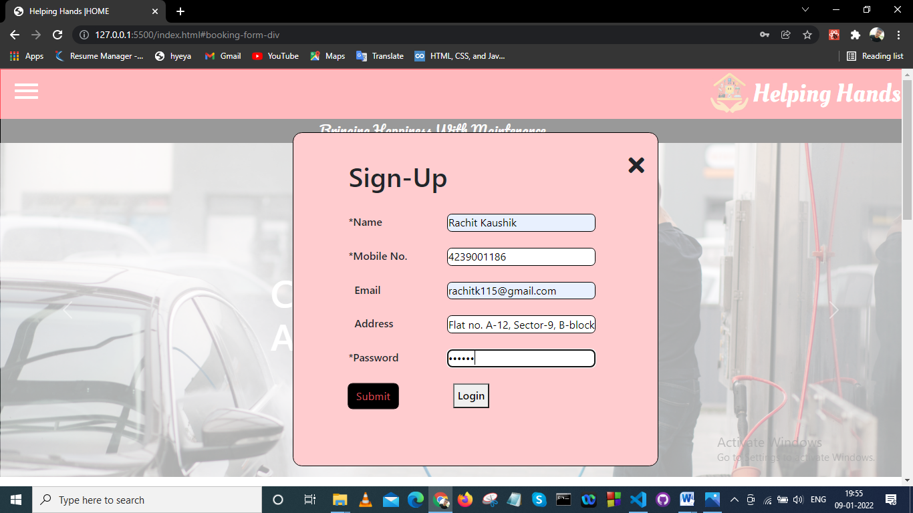

**6.1.8**

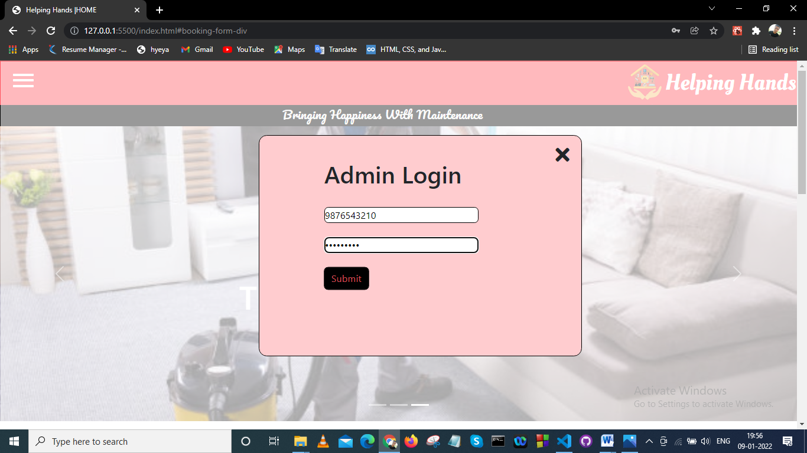

#### 6.1.9

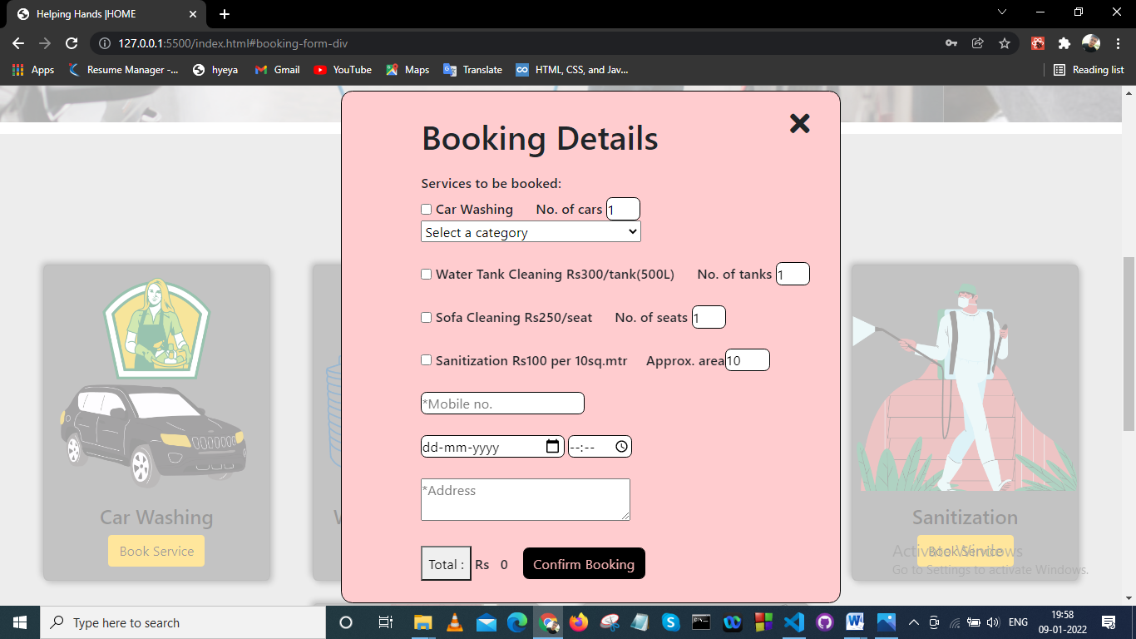

**6.1.10**

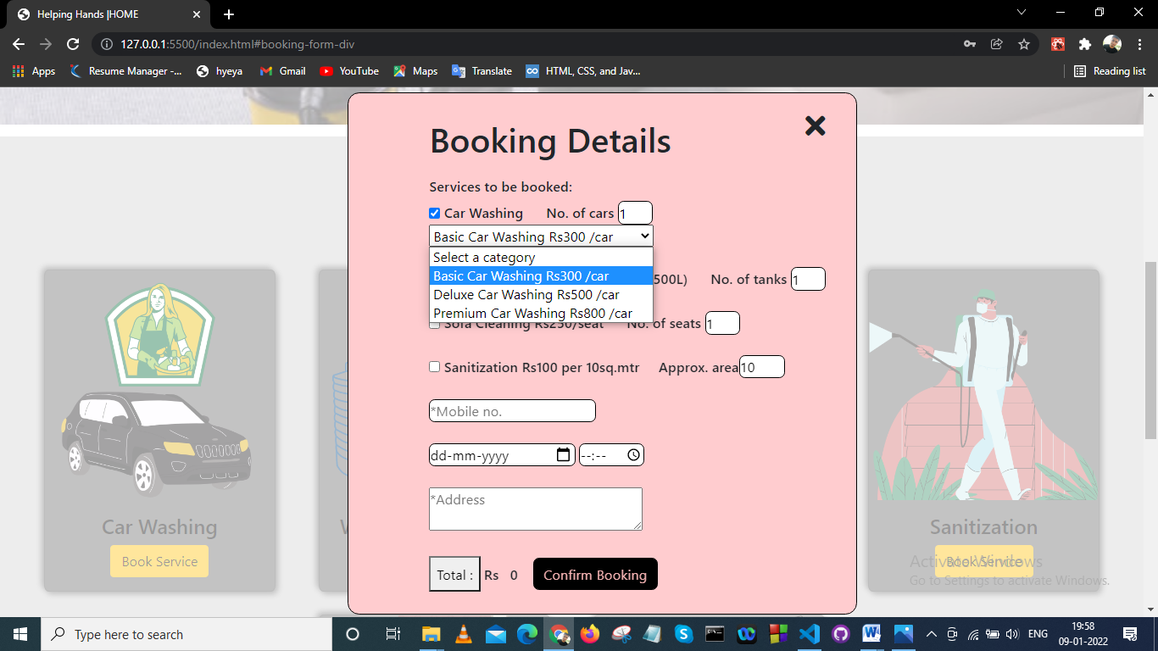

#### 6.1.11

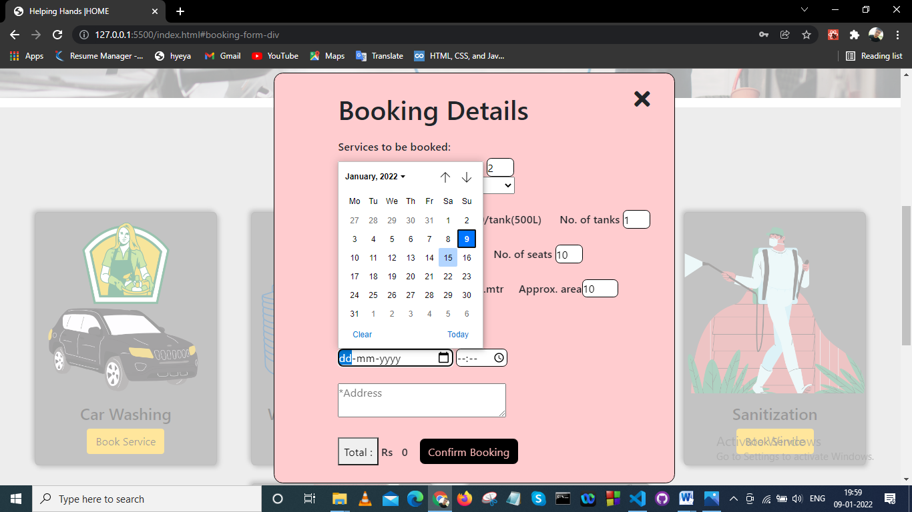

**6.1.12**

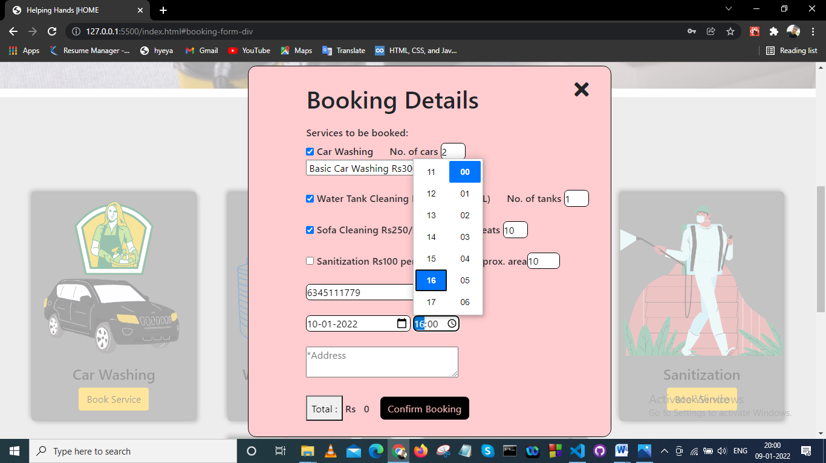

#### 6.1.13

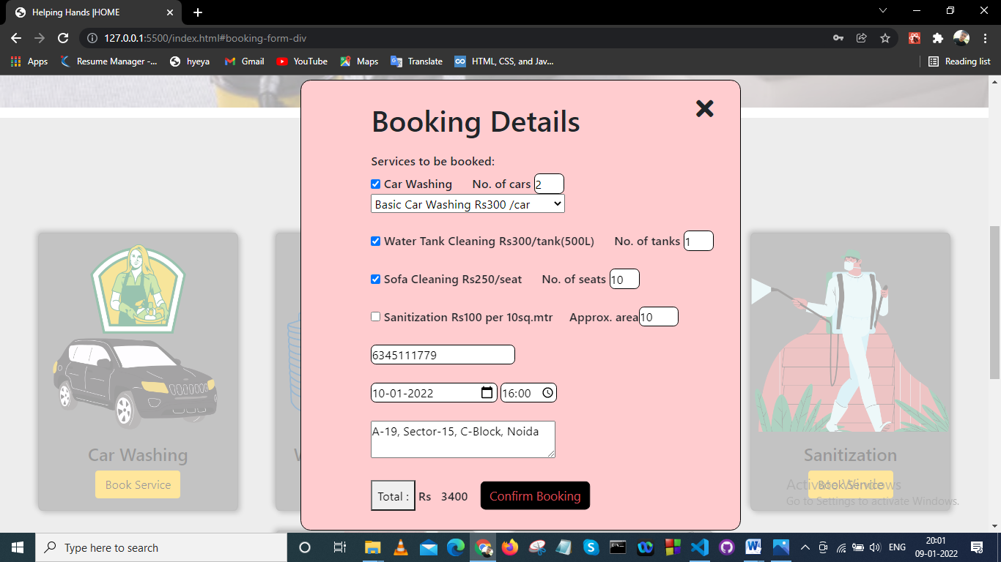

**6.1.14**

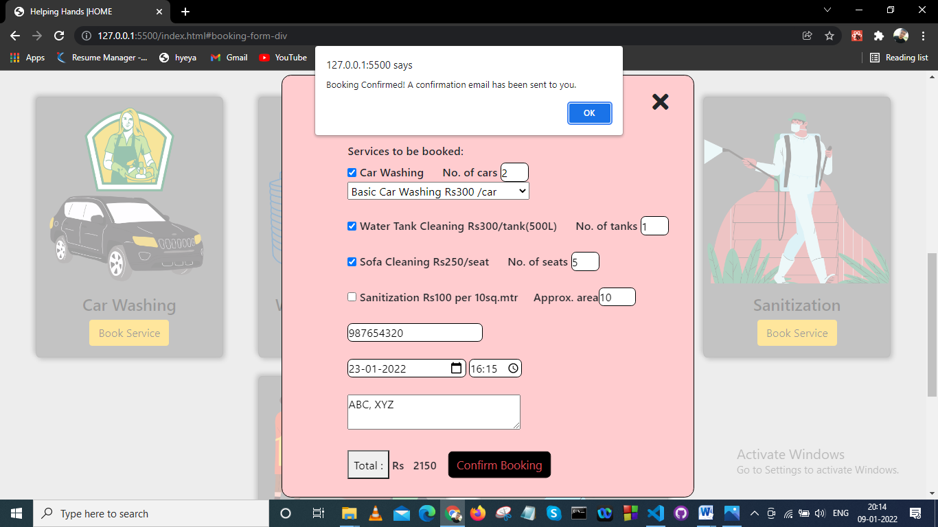

**CODE GLIMPES**

**Front-end:**

**index.html**

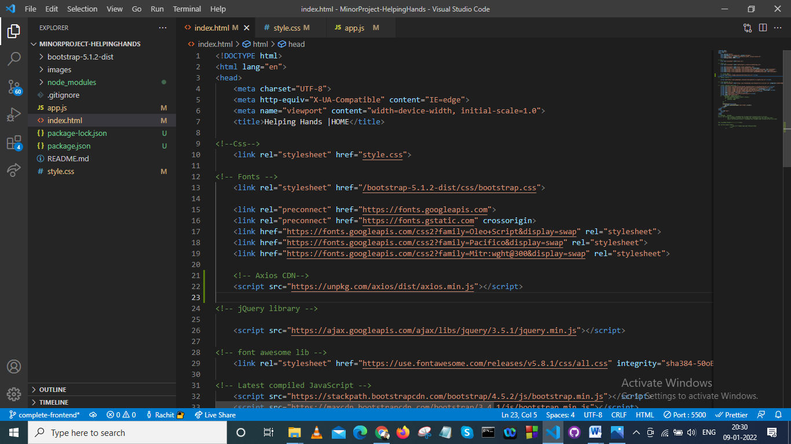

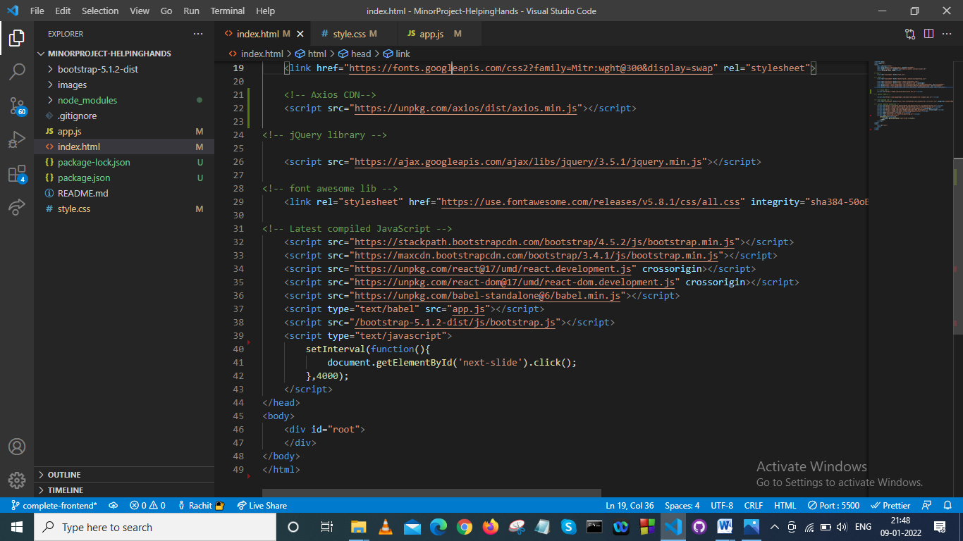

**style.css**

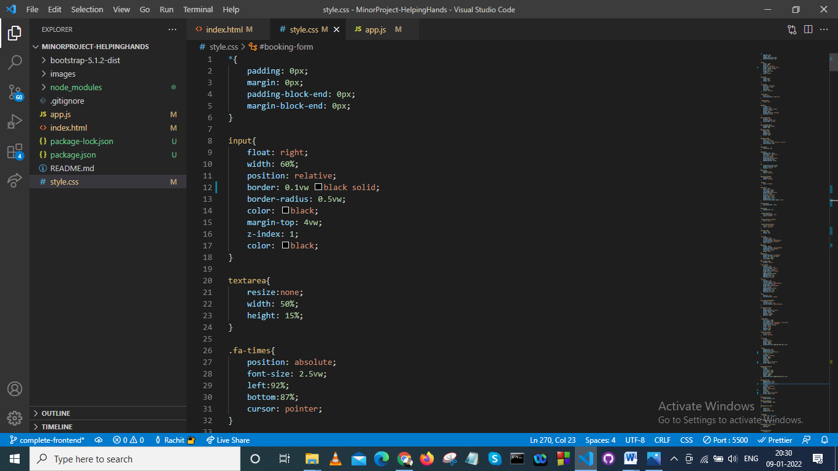

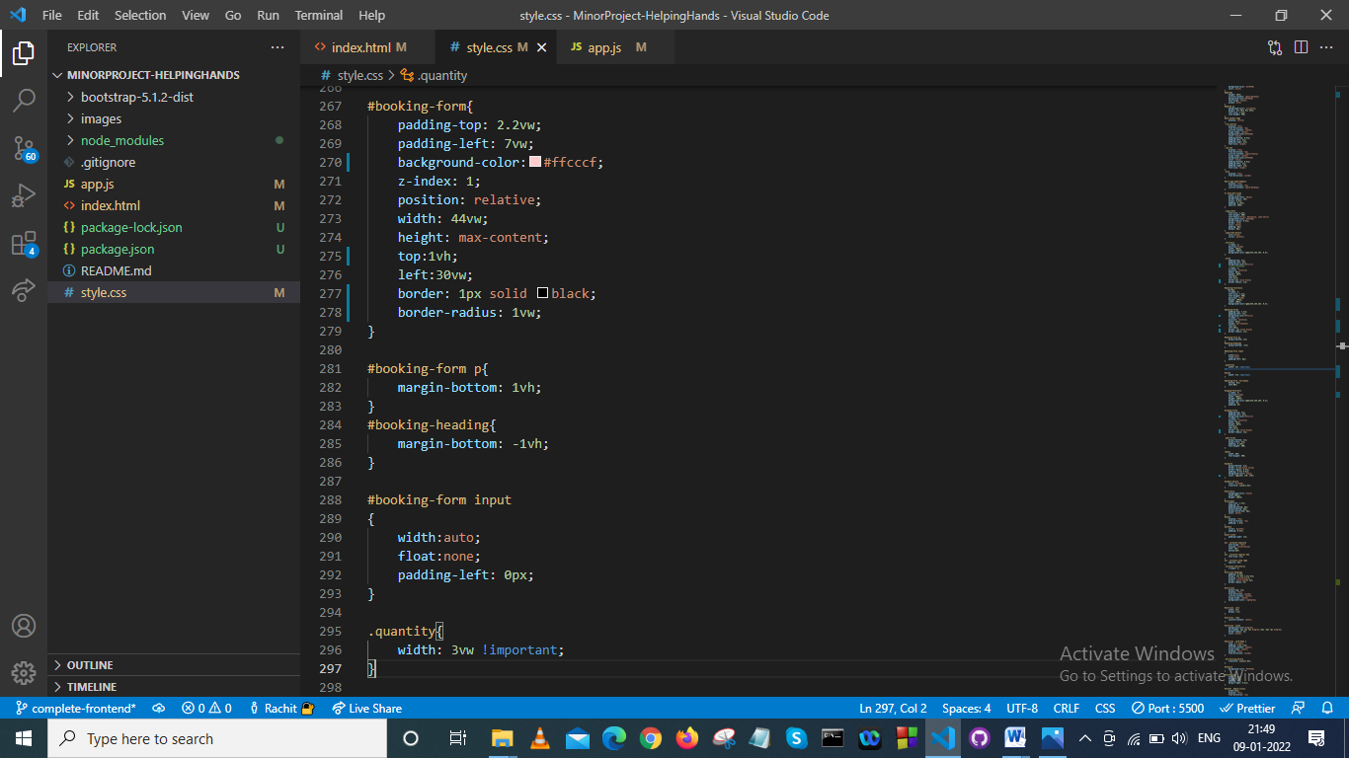

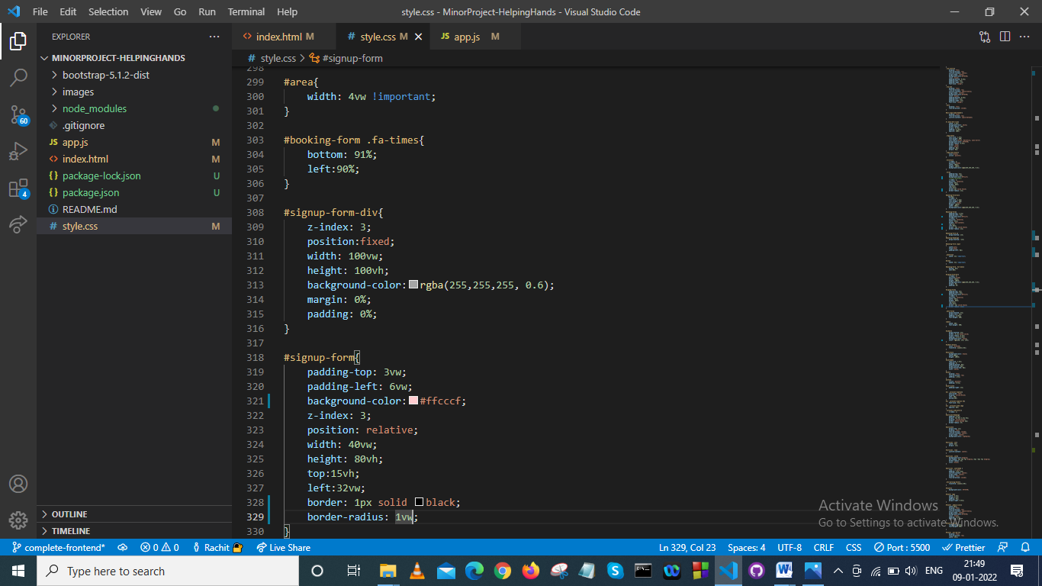

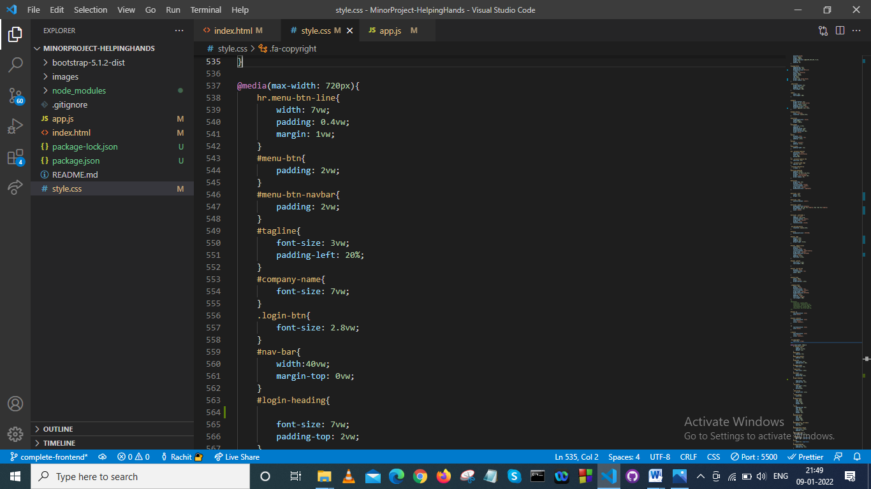

**app.js**

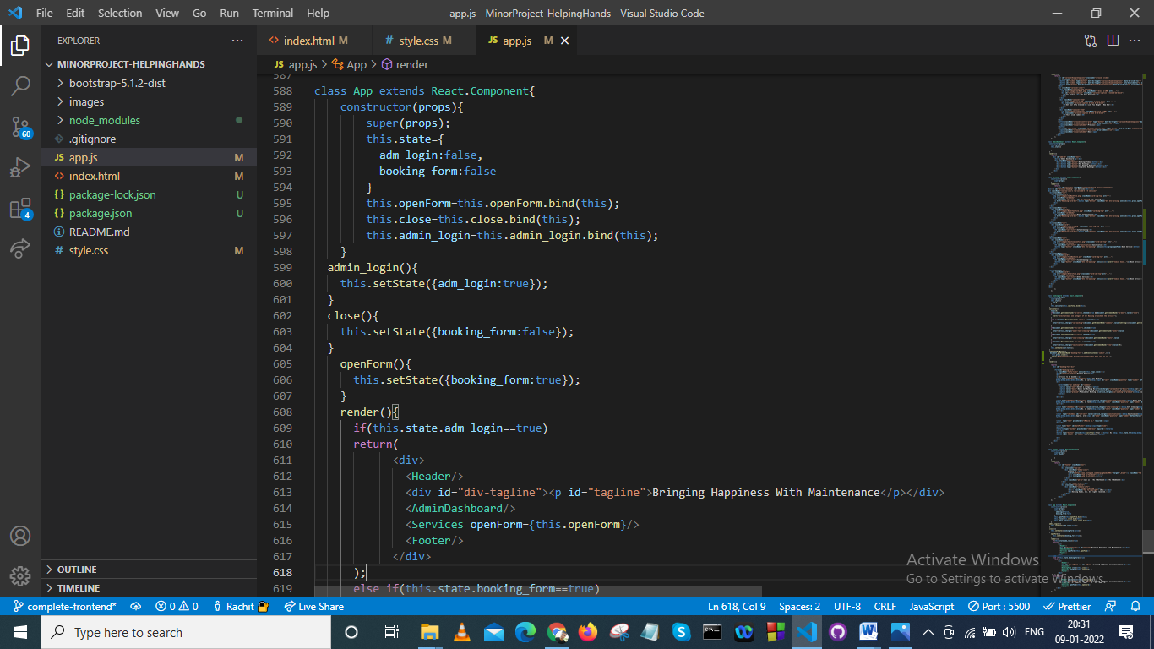

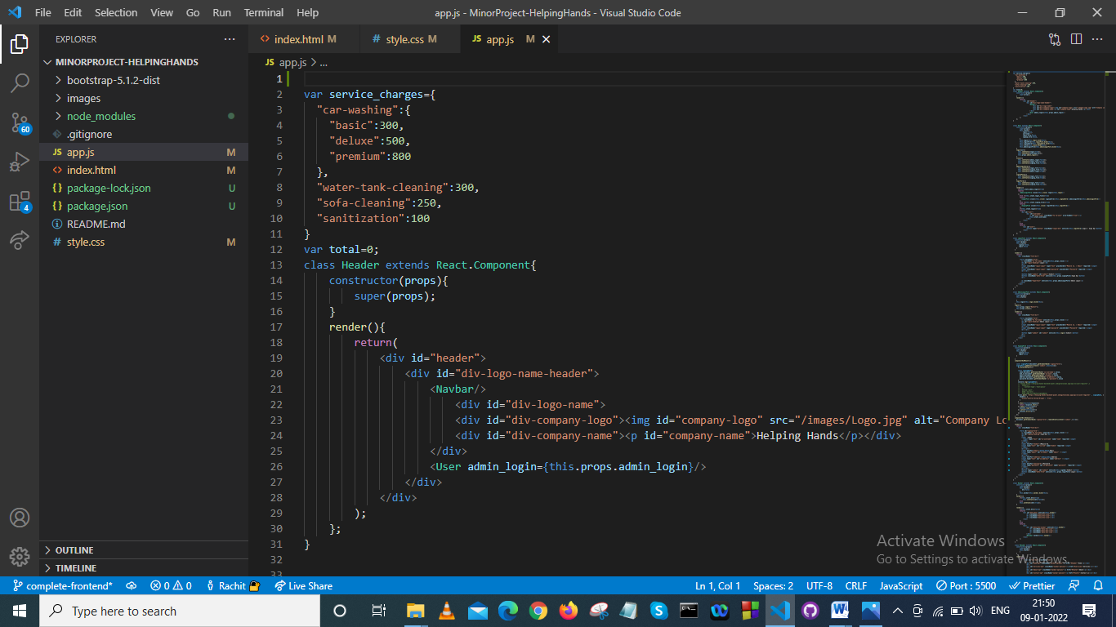

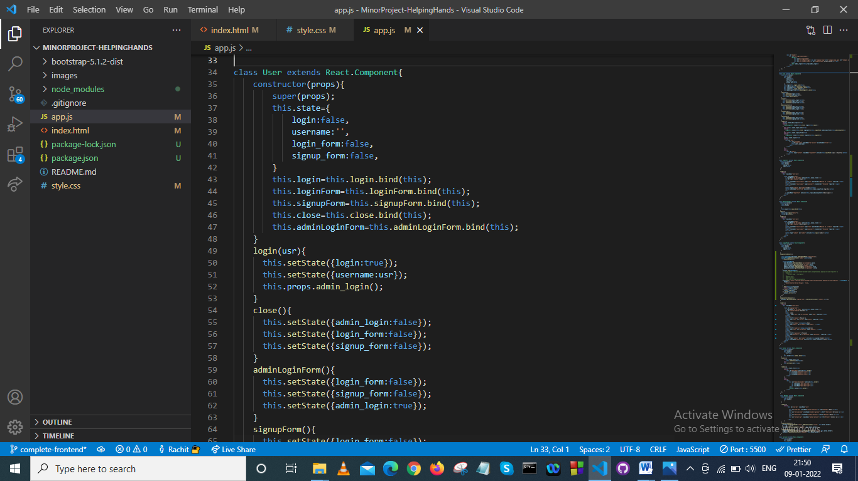

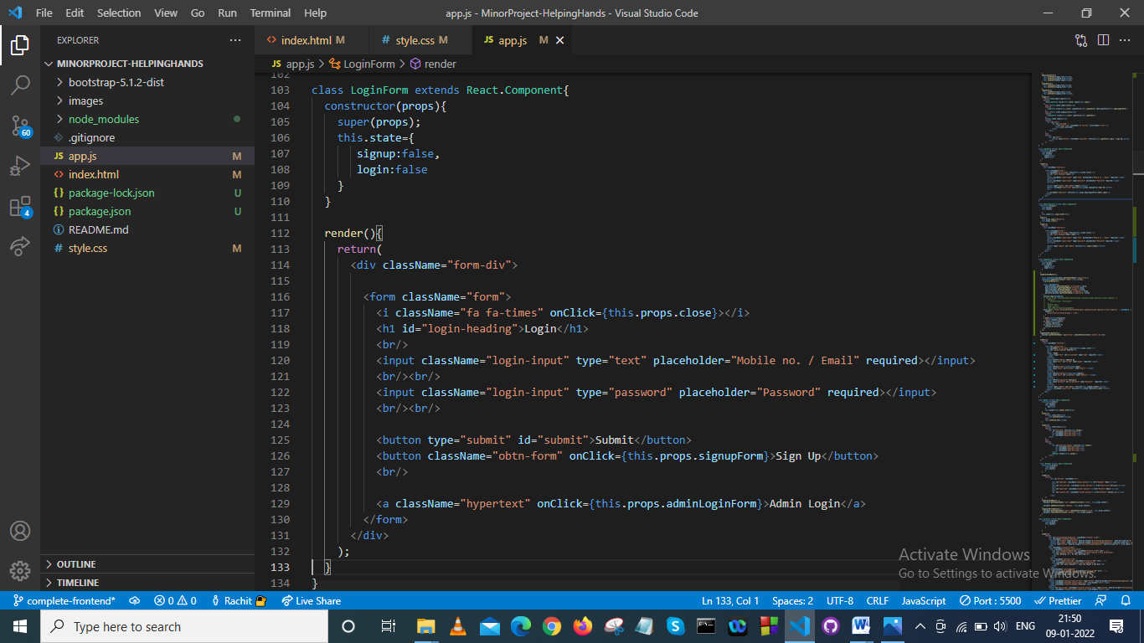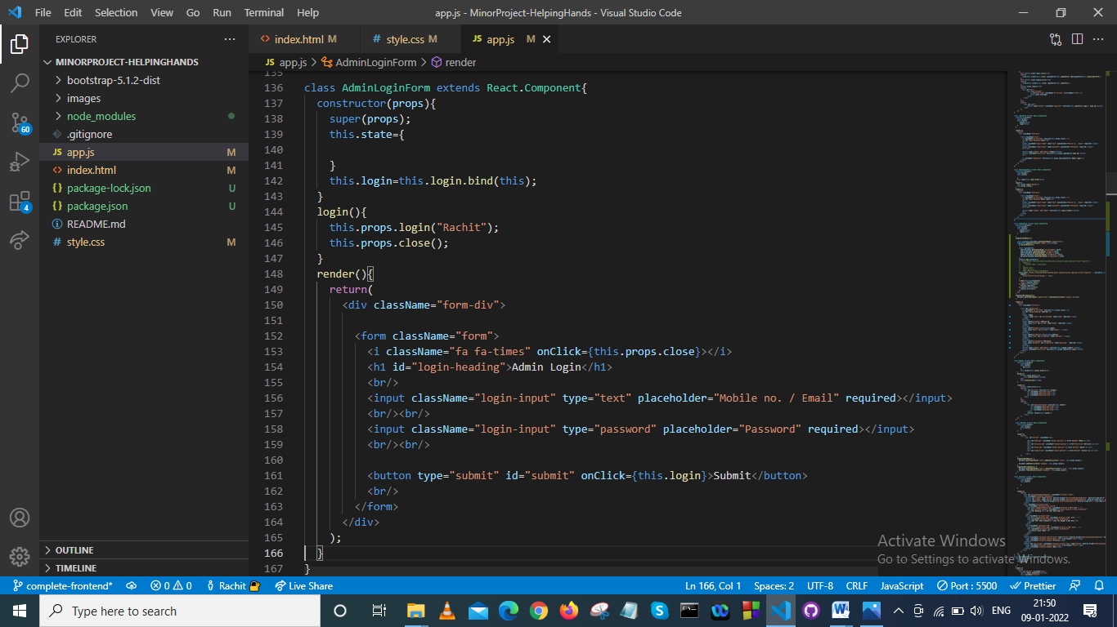

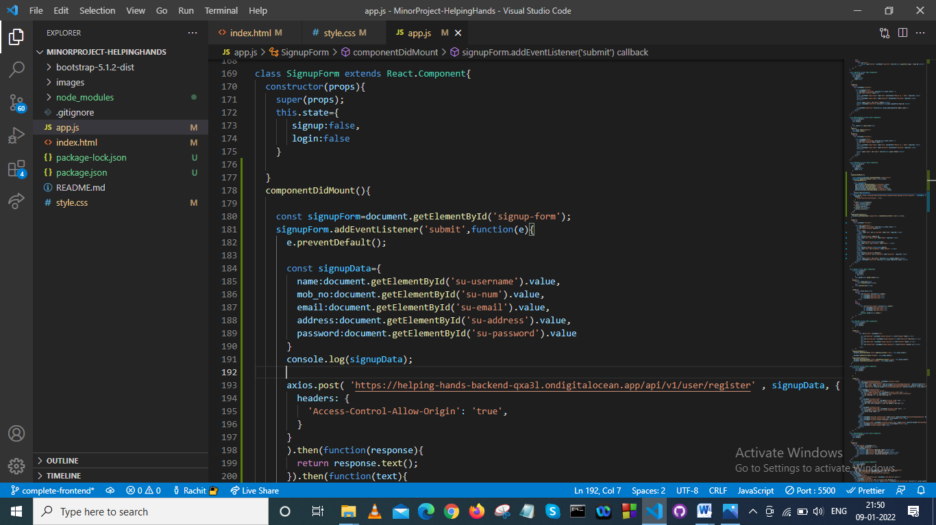

**Backend Endpoints :**

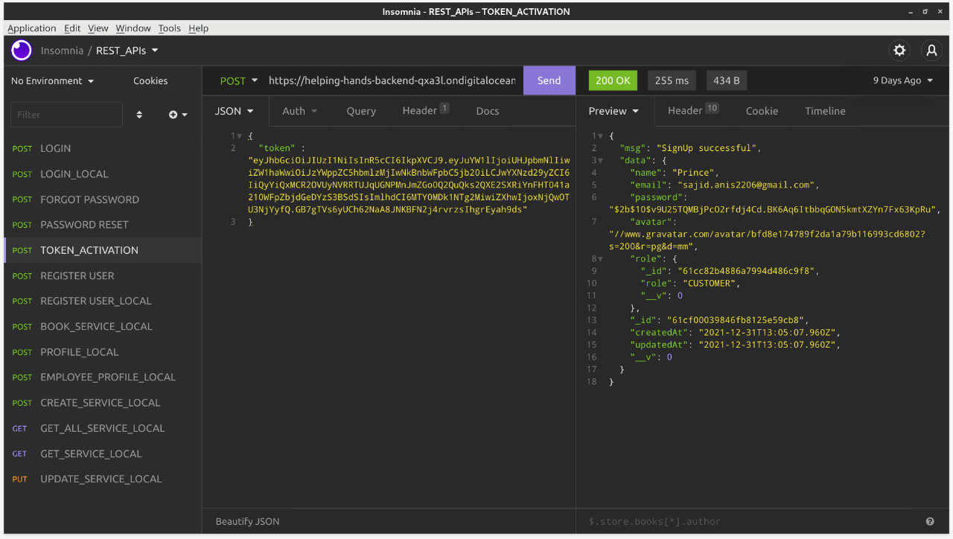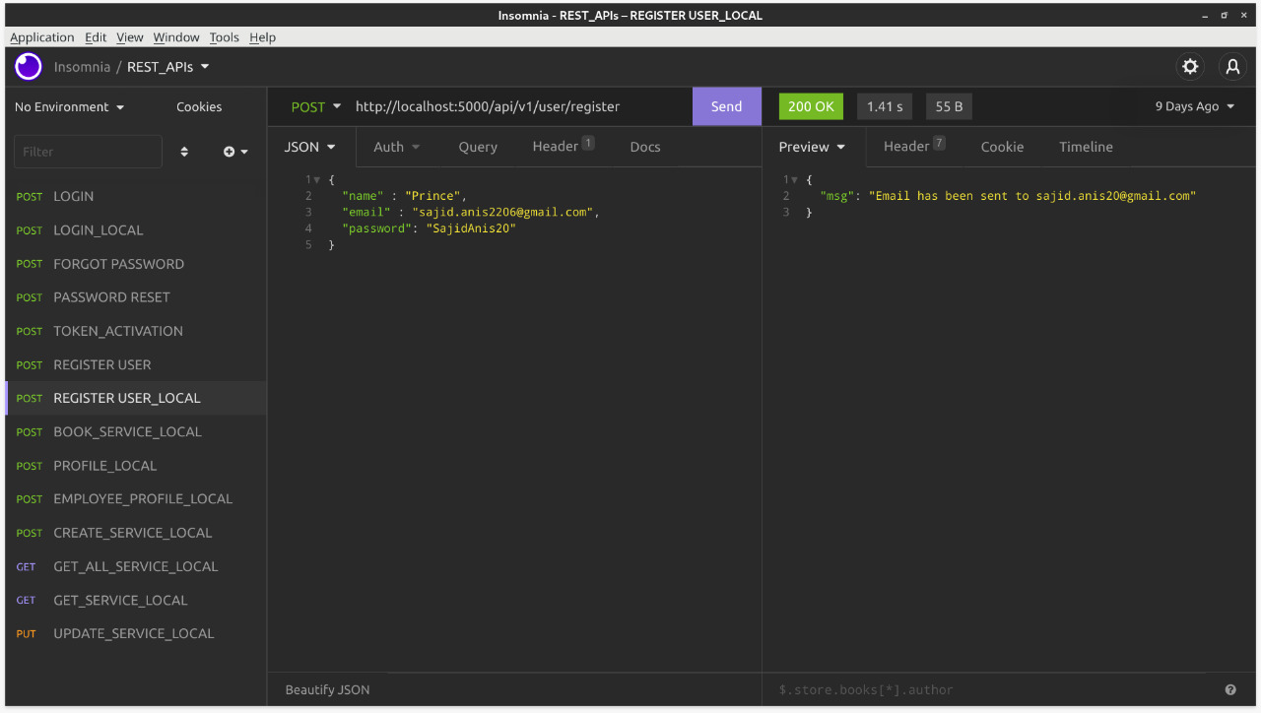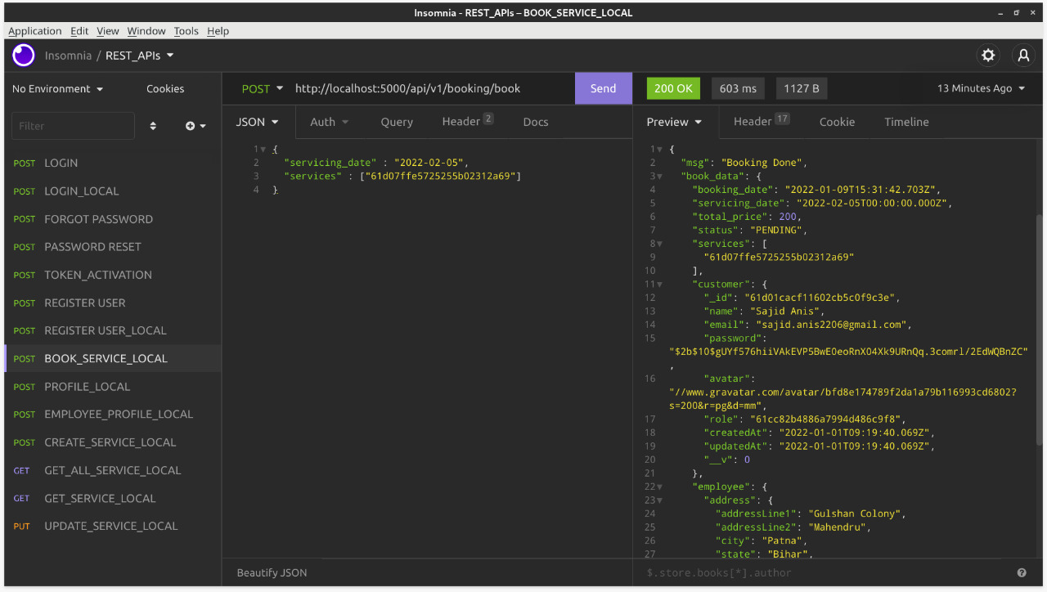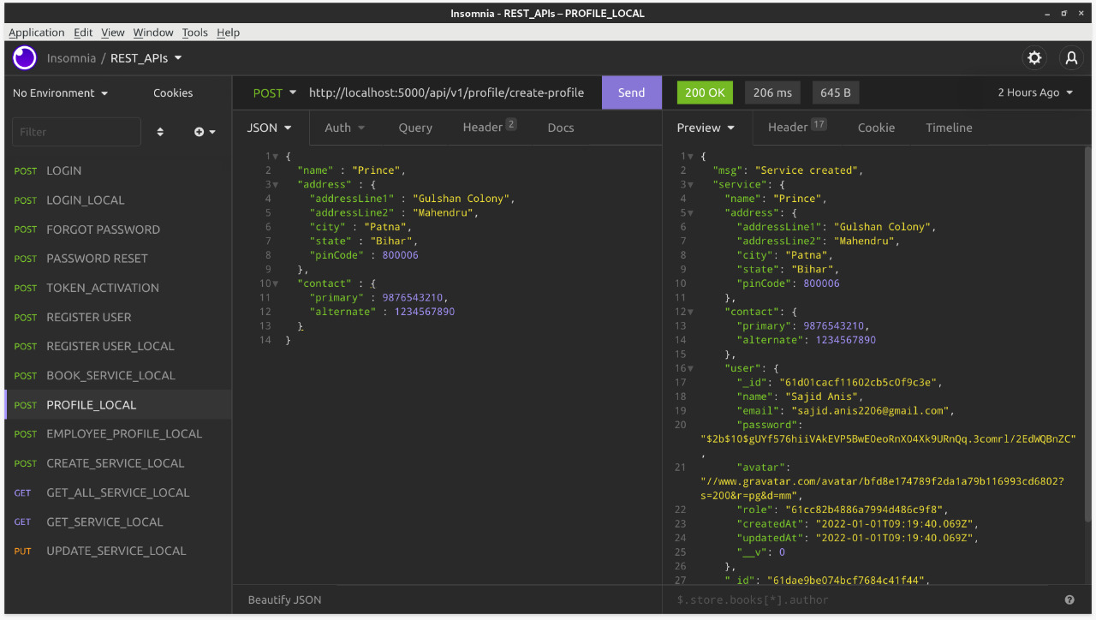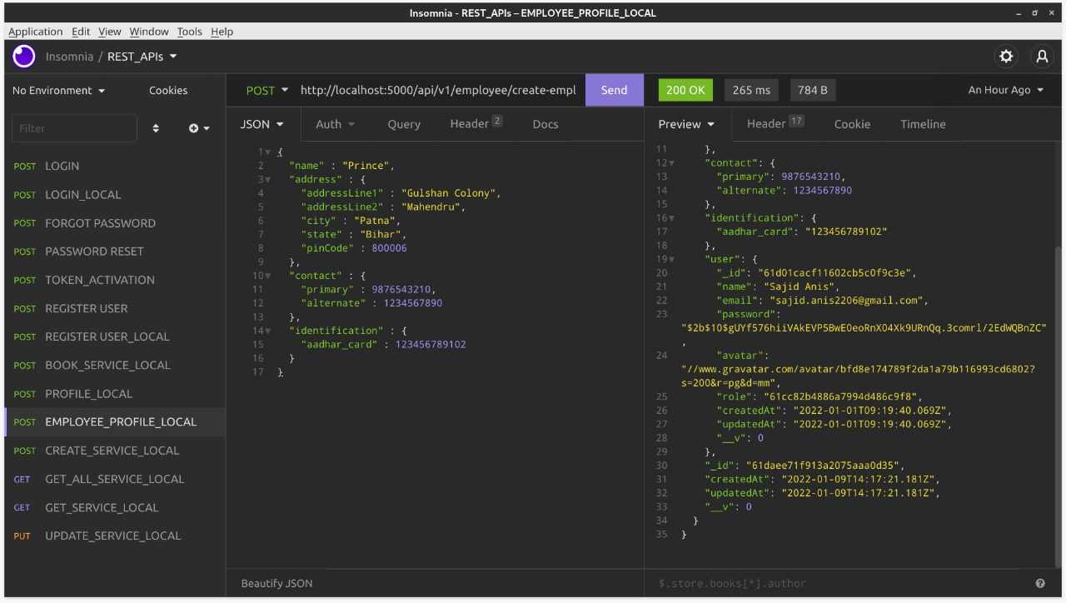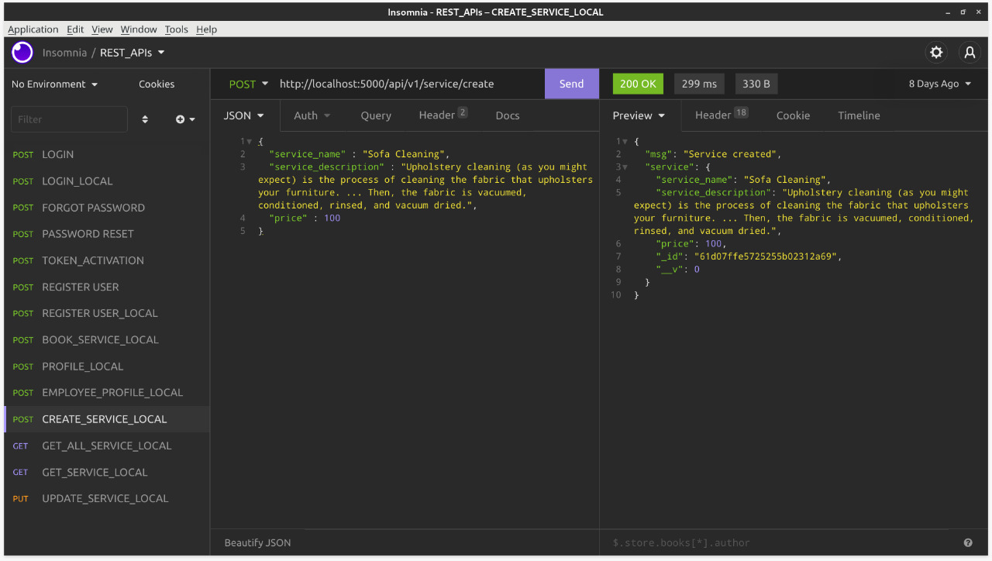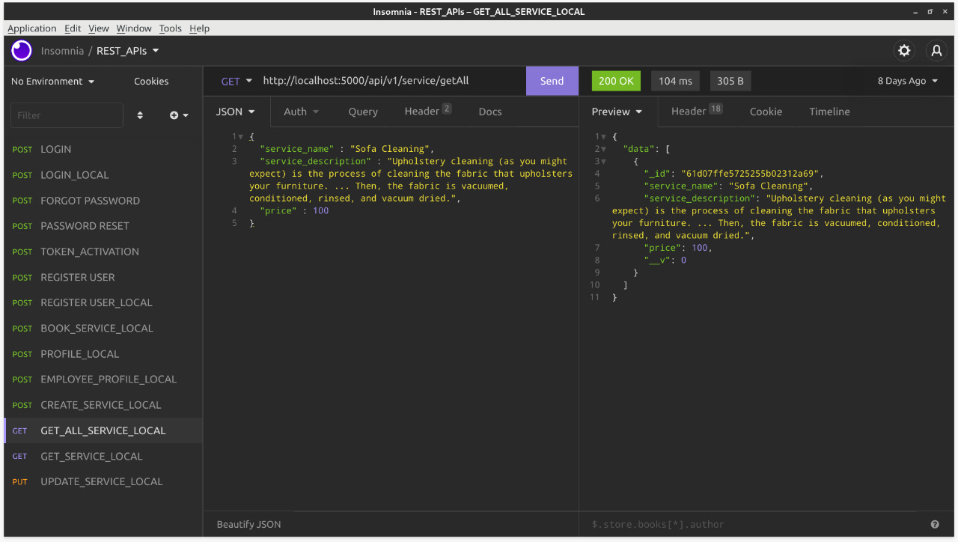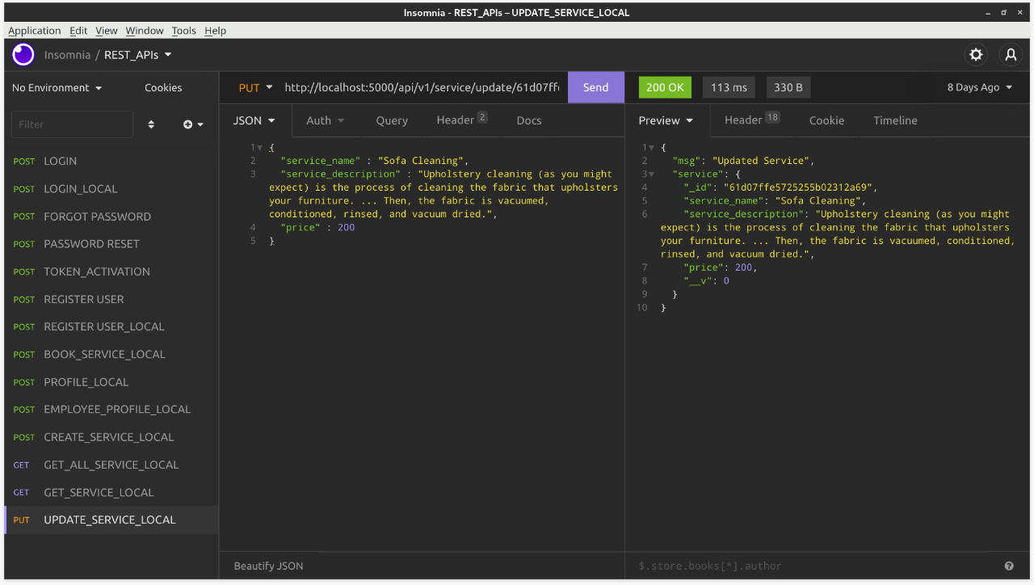

## REFERENCES

## <https://reactjs.org/>

## <https://code.visualstudio.com/docs>

## <https://docs.mongodb.com/>

## <https://expressjs.com/>

## <https://nodejs.org/en/docs/>